Different Scraper Design Ideas:
Jason’s Preferences: Design 1, 7, 6 (in order of preference)

No. | Design | Pros | Cons
1 | Using a similar system to the bucket drum, but with slight differences:  - Use the linear actuation system to lower and raise the scraper  - Use the motor drive arm to tilt/rotate the scraper to deposit the regolith  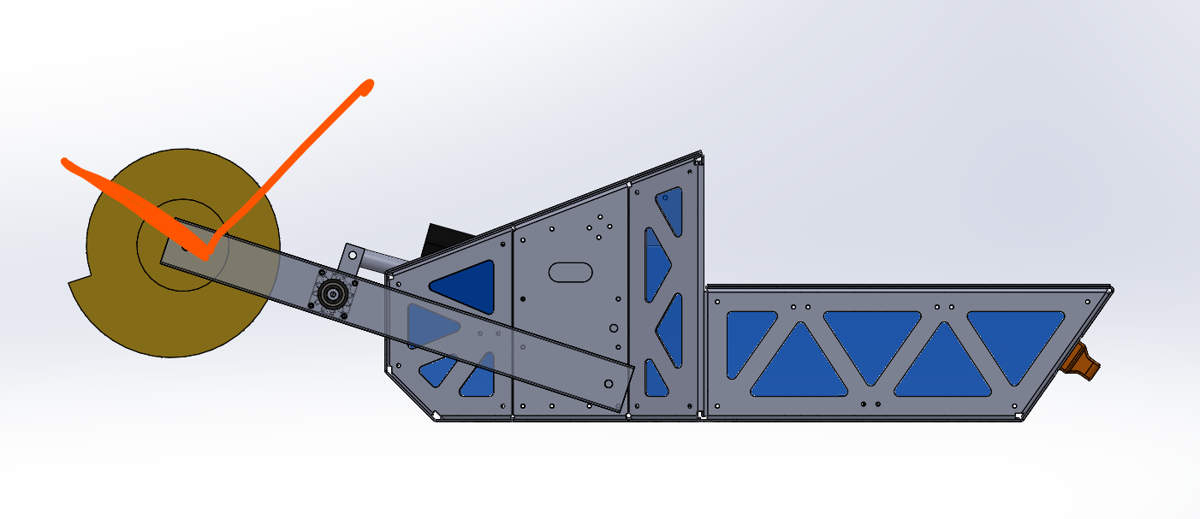  (NB: this design is a combination of Cratos x Nova ARC payload, cratos utilises a rotating shaft)  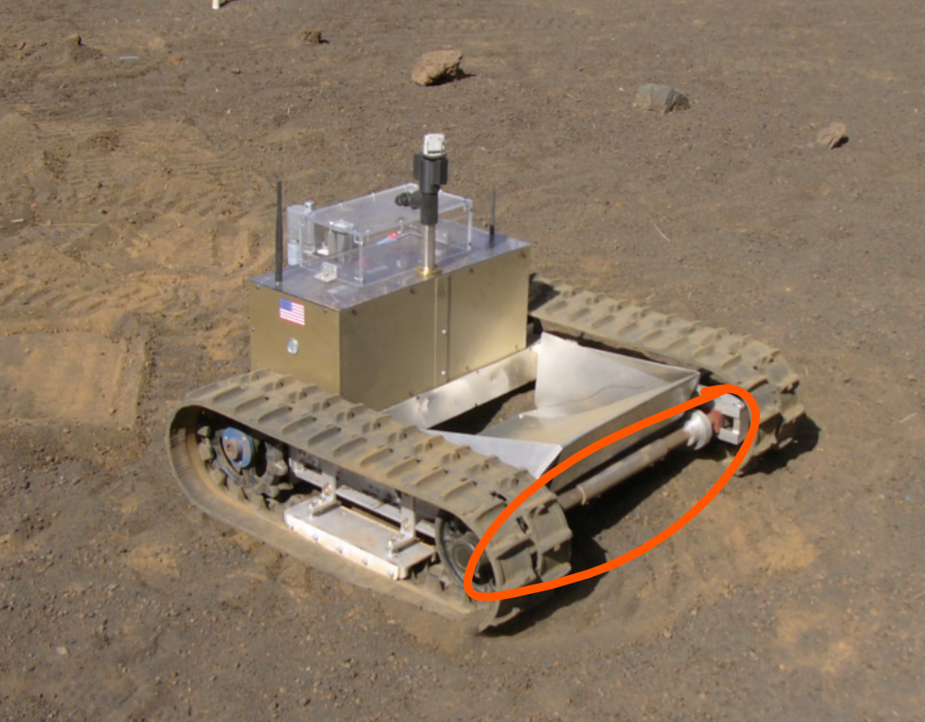 | - Easy to implement into the current ARC payload  - Similar to the bucket drum system = hopefully less work required  - Easy work around to the deposition issue  - Won’t need another payload just for this system | - Will the motor drive arm be strong enough to rotate the regolith ?  - Will the motor drive arm be driven by the regolith ?
2 | A system that utilities only an actuation system to collect and deposit regolith. The system will deposit regolith when it retracts fully up. This would mean that a different sci payload (maybe made out of wood) would be required, with a hole at the front for regolith to fall through  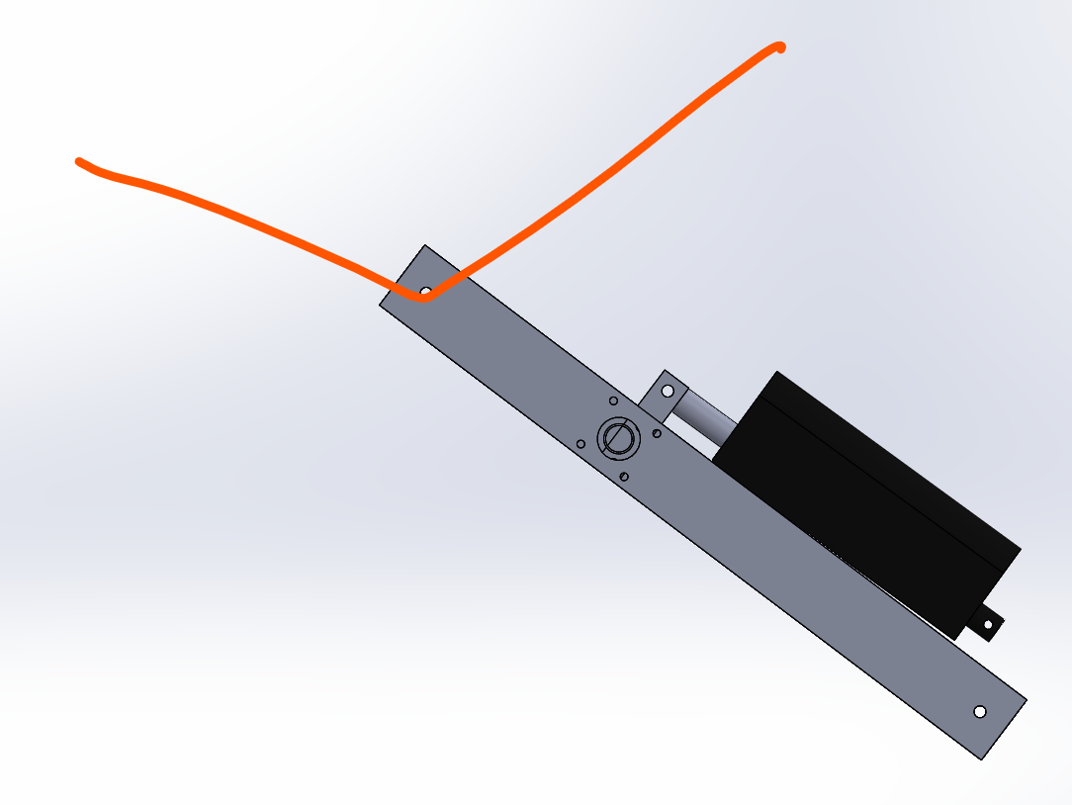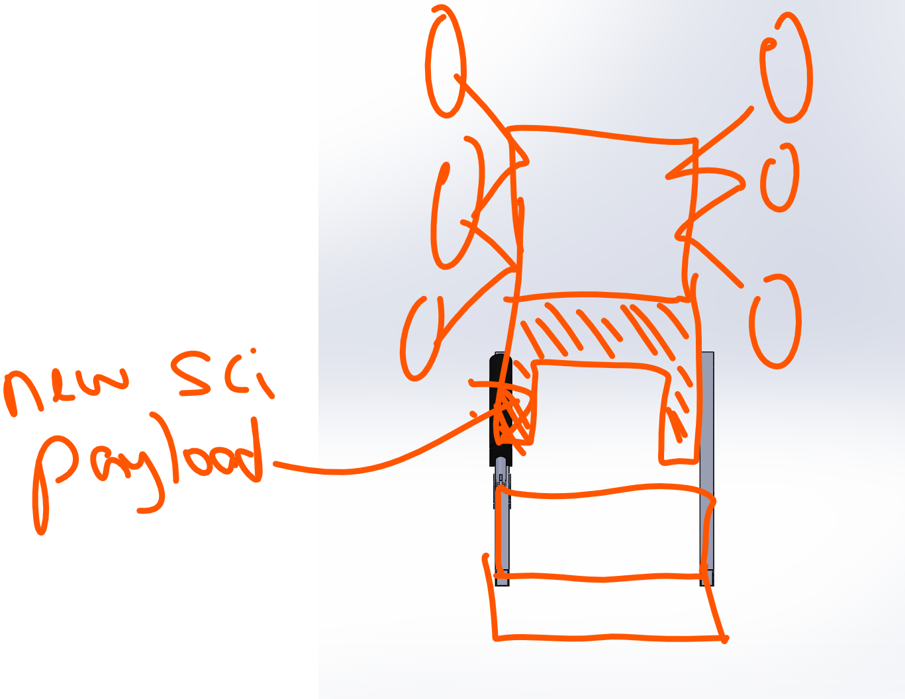 | - Won’t need a rotation mechanism to deposit regolith | - Need to also make a new blackbox science payload  - May be difficult to design this science payload  - May be difficult/impossible to find a good spot that can both collect and deposit regolith ?  - Dust mitigation of new science payload may be an issue?
3 | A system that uses an actuation system to collect regolith and a trap door on the bottom plate that will rotate and open to release the regolith.  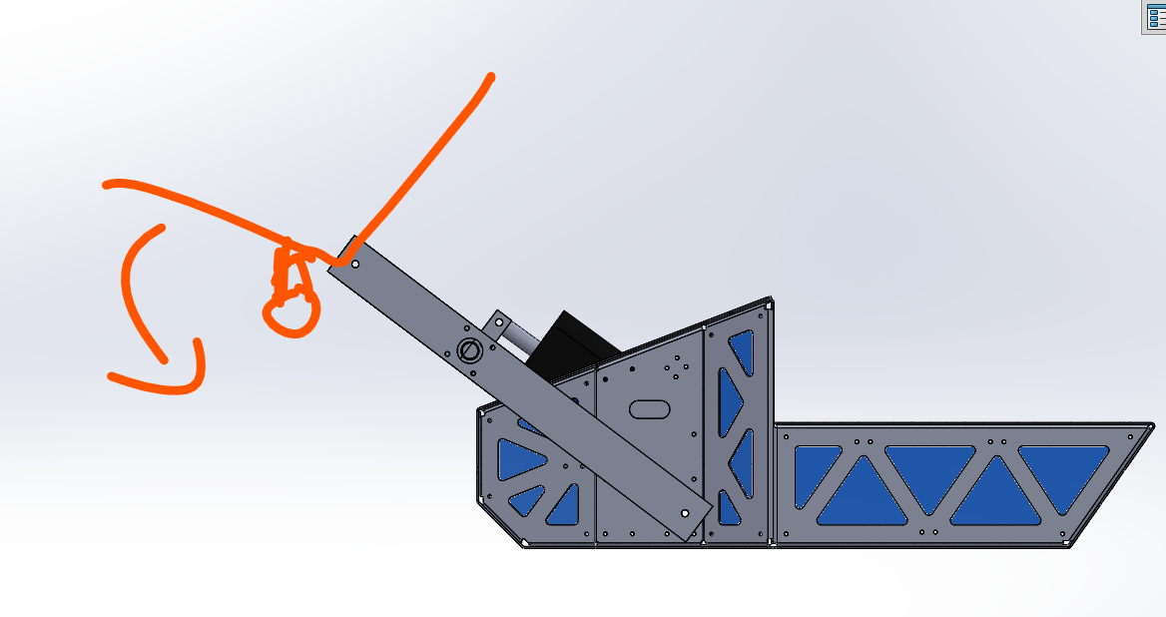 | - Don’t need a science payload | - Will the motor that holds the trap door be driven by the regolith as we collect ?  - Most but not all regolith would be deposited (some would get caught on the trap door rotation system?)
4 | A system that uses an actuation system to collect regolith and a trap door on the top plate that will rotate and open to release the regolith.  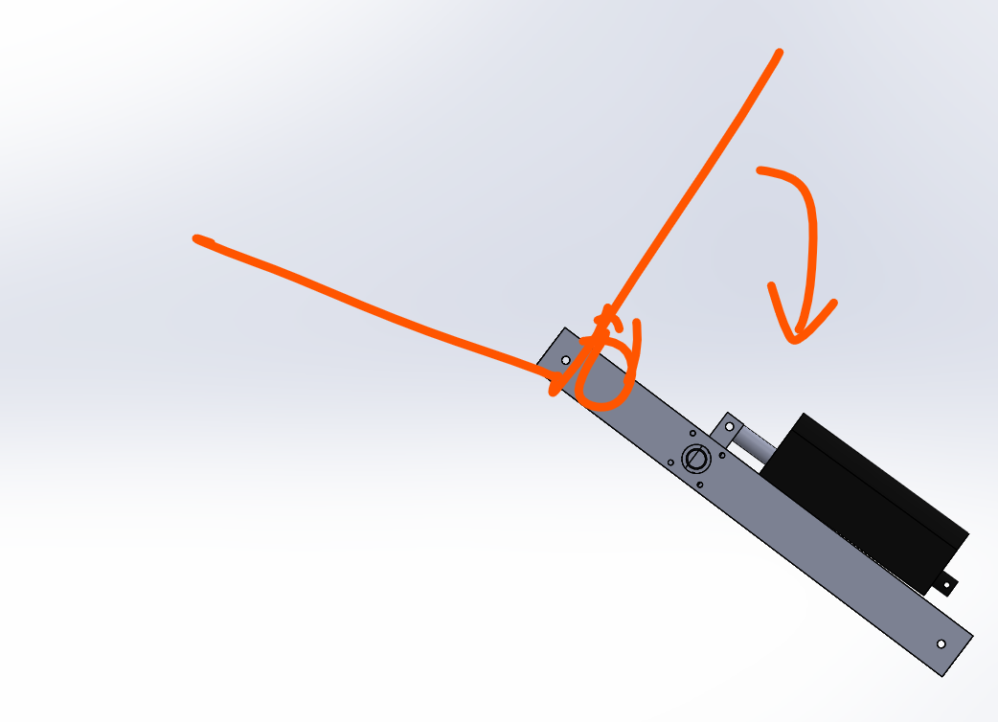   | - Better than design 2 because it’ll be easier to find a spot/position for the linear actuation that can just collect the system | - Need to also make a new blackbox science payload  - May be difficult to design this science payload  - collect and deposit regolith ?  - Dust mitigation of new science payload may be an issue?  - Most but not all regolith would be deposited (some would get caught on the trap door rotation system?)
5 | A system that uses an actuation system to collect and deposit regolith and a massive scrapper to deposit it over the science payload.  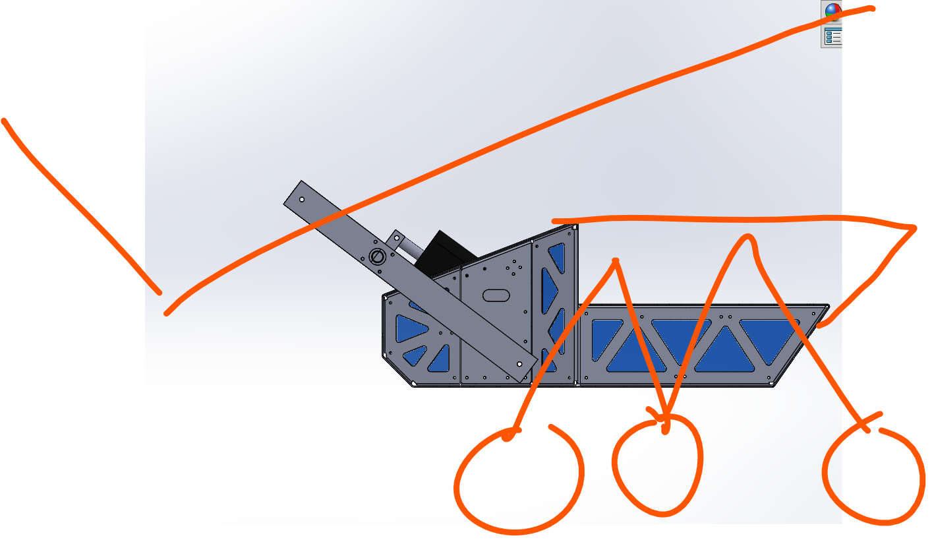 | - Do not have to create a new science blackbox payload like Design 2 or 4. | - Not feasible to have such a long scraper lol  - Not all regolith would be deposited
6 | Use an actuation system to collect and deposit regolith. However, depositing of regolith will occur from tipping the scrapper to the front. The actuation arm will be attached to a wheel. Once regolith has been collected, this wheel will rotate the position of the regolith arm, allowing for regolith to be deposited.  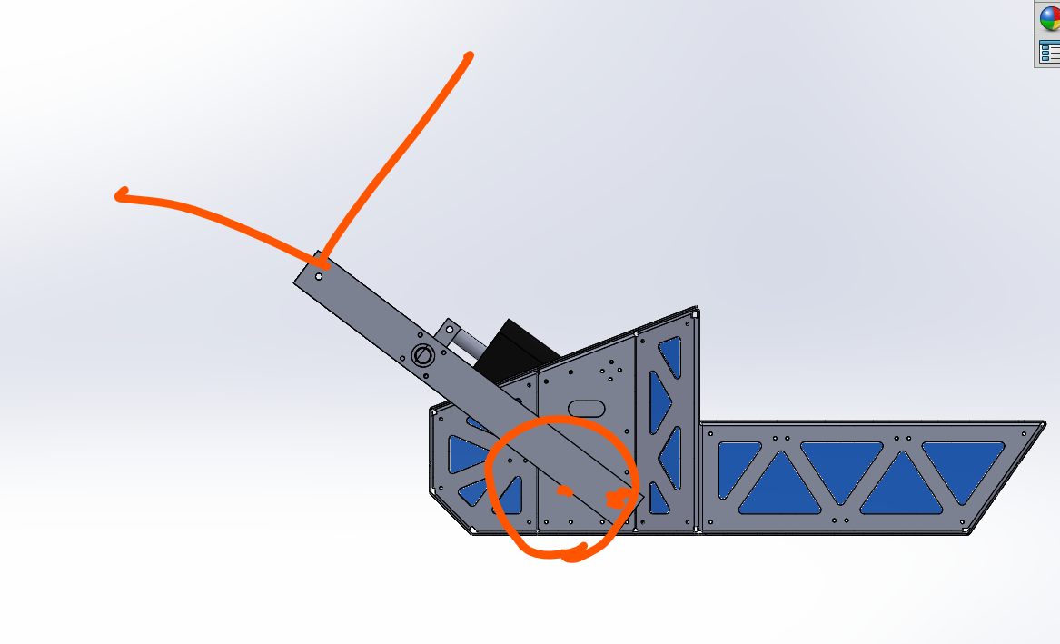 | - Avoids the issue of the motor potentially being driven by the regolith like designs 1 and 3 | - Might not have enough space on the side of the science box to have this rotation system (if so, a work around could be to make a new science payload, but then issues with this are presented above)
7 | Double actuation system  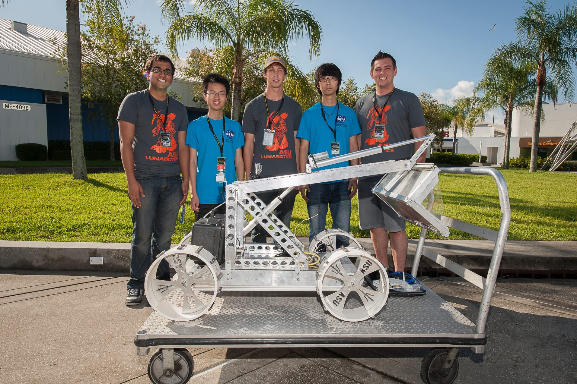 | - Could work well potentially - this team has done reasonably well in the Lunabotics | - Need to also make a new blackbox science payload  - Dust mitigation of new science payload may be an issue?
8 | Utilises a similar system to cratos, whereby it rotates around one shaft to collect regolith. To deposit regolith it rotates the other way and deposits it through the slot  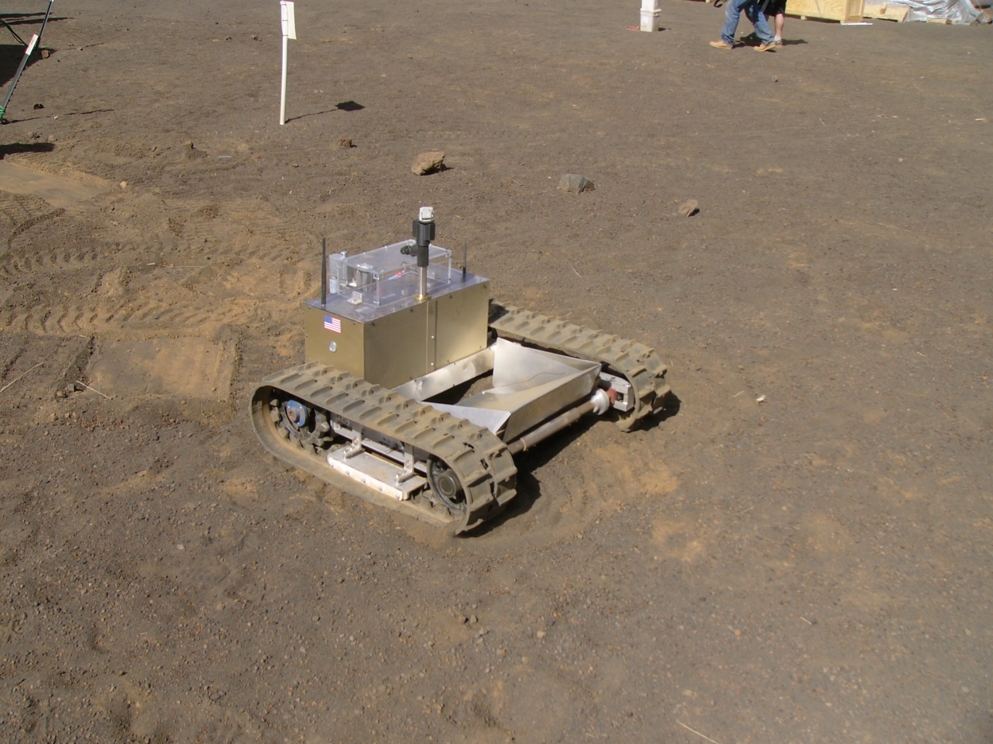   | - CRATTOSSS, what a beast  - Low to the ground | - Sand may get clumped up under the sci payload  - Not all regolith excavated will be deposited in this manner  - Cannot utilise a ramp to deposit the regolith (unlike cratos which does), hence, sand would need to be deposited on the inside  - Need to also make a new blackbox science payload  - Dust mitigation of new science payload may be an issue?

